Project Design Phase-I
Solution Architecture

Date | 19 February 2026
Team ID | LTVIP2026TMIDS89796
Project Name | Heritage Treasures: An In-Depth Analysis of UNESCO World Heritage Sites in Tableau
Maximum Marks | 4 Marks

Solution Architecture:
Solution architecture defines how business needs are transformed into a structured technical solution. In this project, it explains how Tableau dashboards, Flask backend, and the web interface work together to deliver interactive UNESCO World Heritage analytics.
The Goals are:
- Select the best technology to solve the problem.
- Explain system structure and features clearly.
- Define development phases and requirements.
- Provide technical guidelines for building and managing the solution.
Example - Solution Architecture Diagram:

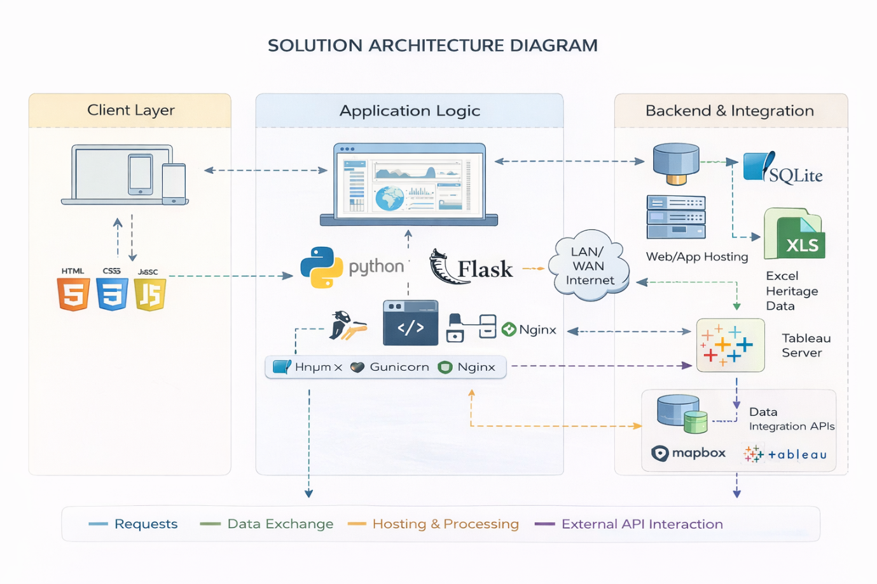
Figure 1: Solution Architecture
Reference: https://aws.amazon.com/blogs/industries/voice-applications-in-clinical-research-powered-by-ai-on-aws-part-1-architecture-and-design-considerations/

